Experiment 1

:Uniform Acceleration

Name: Jonathan Goh

UID: 404901382

Date Performed: 4/18/18

Lab Section: Wednesday 8 a.m.

TA: She, Zhenyu

Partner: Daniel Schwartz

1. Plots
   1. M = 235g, m = 20g

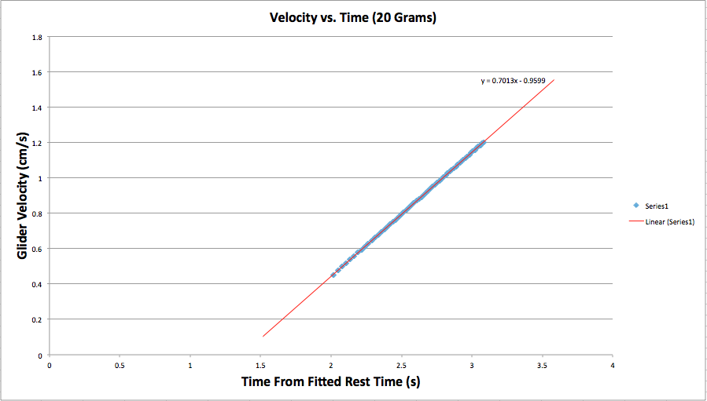

* 1. M = 235g, m = 35g

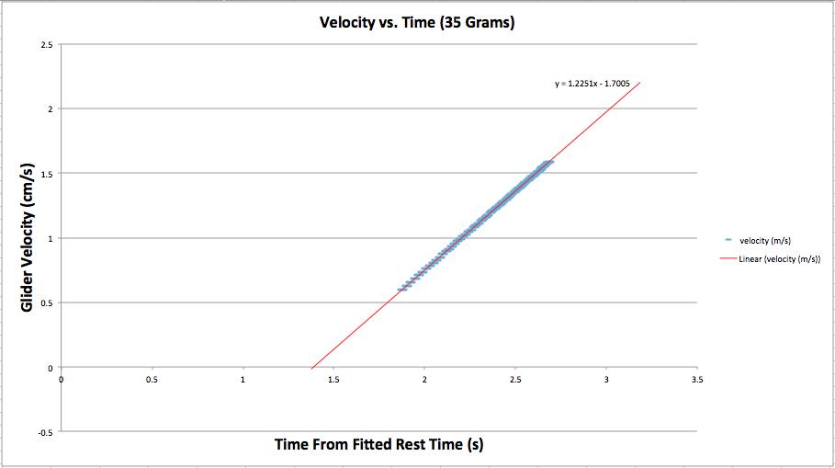

* 1. M = 235g, m = 40g

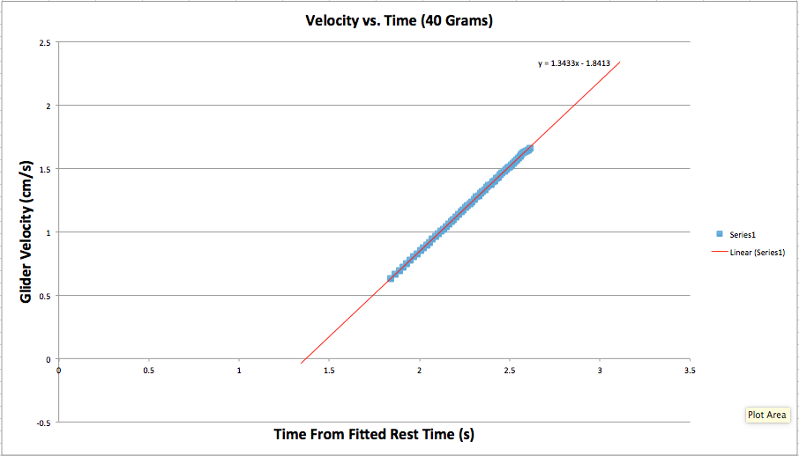

* 1. M = 235g, m = 55g

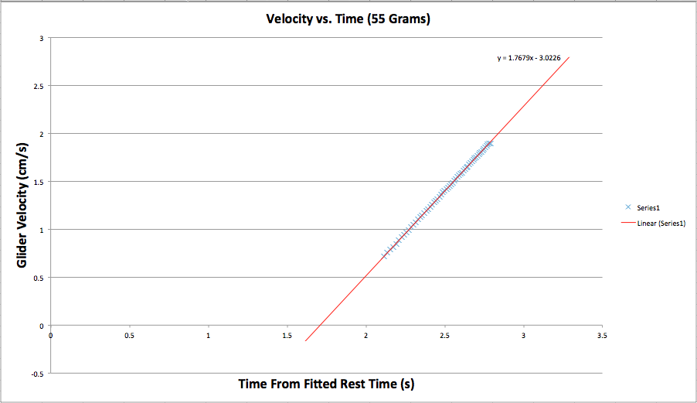

* 1. M = 235g, m = 75g

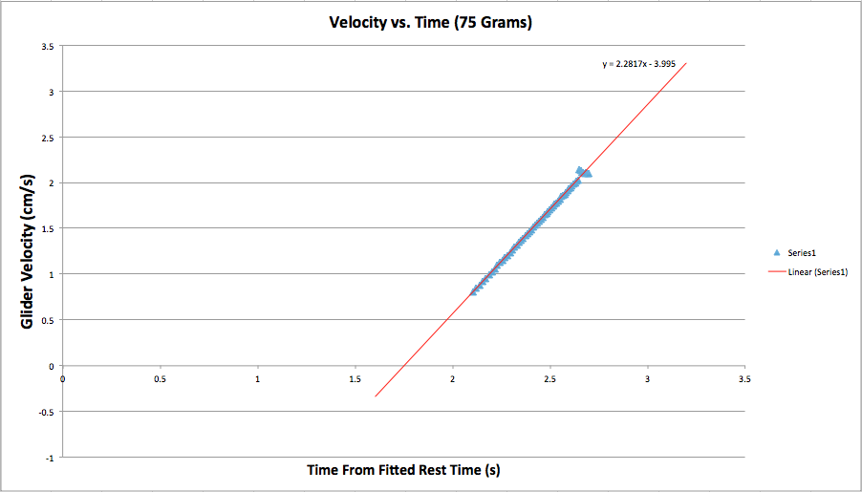

1. Data Table

|  |  |  |  |  |
| --- | --- | --- | --- | --- |
| Trial | Hanging Mass mbest (g) | Glider Mass Mbest (g) | Fit acceleration afit (m/s^2) | Predicted acceleration apredict (m/s^2) |
| 1  2  3  4  5 | 20  35  40  55  75 | 235  235  235  235  235 | 0.7013 ± 0.0005  1.225 ± 0.001  1.343 ± 0.002  1.768 ± 0.002  2.282 ± 0.014 | 0.769 ± 0.002  1.270 ± 0.002  1.425 ± 0.002  1.859 ± 0.001  2.371 ± 0.001 |

1. Derivations

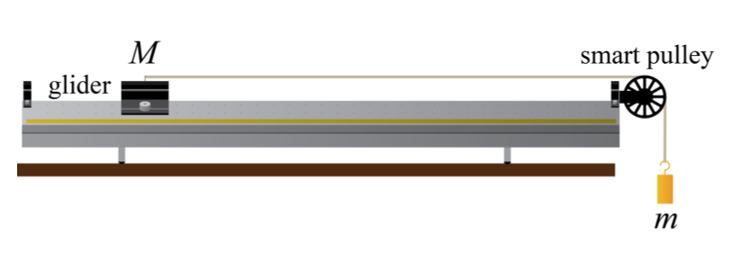

* + 1. Given that:

* + 1. We know that:

* + 1. Substitute :

* + 1. Solve for :

* + 1. Given that:

* + 1. We apply this formula to the deviation produced by acceleration:

* + 1. Next, we must calculate the unknown partial derivatives:

(Derive a with respect to M)

$a=mg(M+m)^{-1}$

$\frac{∂a}{∂m}= ?$

using product rule

$=g(M+m)^{-1}-mg(M+m)^{-2}$

$\frac{∂a}{∂m}=(\frac{g}{M+m}-\frac{mg}{(M+m){}^{2}})$

(Derive a with respect to m)

* + 1. Substitute the calculated partial derivatives into the original equation:

$δa=\sqrt{((\frac{g}{M+m}-\frac{mg}{(M+m){}^{2}}) δM){{}^{2}+((-\frac{mg}{(M+m){}^{2}}) δm){}^{2}}^{}}$

1. Conclusions

The data collected from the experiment shows a directly proportional relationship between Glider Velocity (cm/s^2) and Time From Fitted Rest Time (s). The direct relationship seen in the graphs is also numerically evident after examining the slopes of the trendlines of the data. To enumerate, the slope of the trendline of: the 20g mass is 0.7013, the 35g mass is 1.225, the 40g is 1.343, the 55g is 1.768, and the 75g is 2.282. It is evident that as the mass at the end of the glider is increased, so does the acceleration (slope). In addition, based on the, almost-linear data sets it can be seen that each test case showed a close to constant acceleration since the slope stayed fairly constant as time passed.

When comparing the Fit Acceleration and the Predicted Acceleration there are slight differences, so they agree to a certain extent. To account for the minute differences between what was predicted and what was calculated, it is important to note that the system was not perfect. The glider track that was used to collect data did not have zero friction, even though the airflow minimized contact, there was still slight amounts of friction. When calculating the predicted acceleration the assumption is that there is zero friction between the glider and the track. Friction is the first source of error from the experiment. The second source of error arises from the fact that the measurement devices are not perfectly accurate, ideally a measurement device would have infinite precision. These sources of error explain the reason why there are slight discrepancies between the predicted acceleration and the observed acceleration. In order to improve the experiment the data should be collected with a track that has zero resistance and the device used to collect numerical data should be infinitely precise.

**Presentation Mini-Report**

**:The Blue LED**

Light Emitting Diodes (LEDs) are special semiconductors that emit light when they are activated. The first LEDs were made in the early 50’s and 60’s, and had the ability to emit wavelengths that varied from the ultraviolet spectrum to the infrared spectrum. Changing the wavelength of emission was achieved by using different chemicals to produce different colors, however, creating an LED that emitted blue light was troublesome. A blue LED required carefully-crafted crystals that were designed in the lab, however, such discoveries had not yet been made.

It was not until the 1990s that the first blue LEDs were created by three Japanese scientists. The advancement in LEDs was groundbreaking enough to warrant a Nobel Prize in Physics. Isamu Akasaki and Hiroshi Amano, worked together to produce gallium nitride, a chemical that appears in many of the layers in a blue LED, and is integral to blue light. With their knowledge, the two discovered efficiently emit light from the diode by mixing several chemicals with the gallium nitride to build structures with layers of gallium nitride alloys.

Even more astonishing is the application of the blue LED. The modern, white light is easy to make from blue LEDs. Engineers use the blue LED to excite a fluorescent chemical, which in turn converts the blue light to white light. The white light created from such an LED is not only much more energy-efficient, but also has a longer lifespan than that of traditional incandescent lights. The modern white LED converts approximately 50 percent of electrical input into light energy. In comparison to the traditional incandescent light bulb which converts only a mere 4 percent of electricity into light energy. In addition,LEDs have a lifespan of up to 100,000 hours, while fluorescent lights have a lifespan of about 10,000, and incandescent lights have a lifespan of about 1,000 hours.

A byproduct of LEDs is the significant reduction in the world's use of electricity and use of material for lighting. LEDs are such a vast improvement because they convert electricity directly into photons of light, instead of wasting energy as heat generated inside both incandescent and fluorescent bulbs.

The world is oblivious to the fact that blue LEDs are practically everywhere. Without blue LEDs there wouldn’t be backlit smartphones, Liquid Crystal Display (LCD) screens, Blu-ray players, and countless other technological innovations. In the case of Liquid Crystal Displays, LEDs are used to provide backlighting for smartphones, laptops, and televisions. LEDs are not only more energy-efficient than other backlighting methods, but also allow for slimmer displays. Energy efficiency with backlights is especially important when dealing with larger screens on televisions, because the bigger the screen, the more power that it will require. Another common application of blue LEDs is in Blu-ray players, which use blue LED lasers to read data from a digital optical disc. Before Blu-ray players, DVD players used infrared lasers to read data off of discs, but with the advent of Blu-ray, it was possible to store up to 10 times more data than was previously possible with DVDs

Blue LEDs have started to branch out to even more use; currently, LED technology is starting to be used to purify water. The majority of purification plants use mercury lamps to kill microbes in drinking water, the only problem is that these types of lamps use large amounts of electricity. Scientist are in the process of developing LED water purification, and it is projected that it will be universally used in a few short years.

LEDs have expanded from a simple light source, to an integral part of day-to-day technology. As previously mentioned, Blue LEDs have a multitude of practical uses and applications in may different fields. As time progresses, there is no telling how much more efficient and powerful Blue LEDs will become, its potential uses for future technology are endless.

**Word Count: 644**

Bibliography:

1. Campbell, W. C. et al. Physics 4AL: Mechanics Lab Manual (ver. August 31, 2017). (Univ. California Los Angeles, Los Angeles, California).
2. Streubel, Klaus P., and Heonsu Jeon. Light-Emitting Diodes: Research, Manufacturing, and Applications XI: 24-25 January 2007, San Jose, California, USA. *SPIE*, 2007.
3. Nakamura, Shuji. The Blue Laser Diode The Complete Story. *Springer Verlag*, 2010.
4. Normille, Dennis. *The Future Looks Bright For Blue LEDs. Popular Science,* Vol 247. 48. 1995.